**NAME: SHASVAT NIMESH SHAH**

**SAP ID: 60004220126**

**DIV: B**

**TOPIC:** DE

**Experiment Number:** 1

**DATE:**

**AIM: -**

Verification of the truth tables of TTL gates.

**APPARATUS REQUIRED: -**Digital lab kit, single strand wires, breadboard, TTL IC’s AND (IC-7408), OR (IC-7432), NAND (IC-7400), NOR (IC-7402), NOT (IC-7404) and NOR (IC-7486).

**THEORY:-**

Logic gates are idealized or physical devices implementing a Boolean function, which it performs a logical

operation on one or more logical inputs and produce a single output. Depending on the context, the term may refer

to an ideal logic gate, one that has for instance zero rise time and unlimited fan out or it may refer to anon-ideal

physical device.

The main hierarchy is as follows: -

1. Basic Gates

2. Universal Gates

3. Advanced Gates

**BASIC GATES**

**AND GATE:**

The AND gate performs a logical multiplication commonly known as AND function. The output is high when both

the inputs are high. The output is low level when any one of the inputs is low.

**OR GATE:**

The OR gate performs a logical addition commonly known as OR function. The output is high when any one of the

inputs is high. The output is low level when both the inputs are low.

**NOT GATE:**

The NOT gate is called an inverter. The output is high when the input is low. The output is low when the input is

high.

**UNIVERSAL GATES**

**NAND GATE:**

The NAND gate is a contraction of AND-NOT. The output is high when both inputs are low and any one of the

input is low. The output is low level when both inputs are high.

**NOR GATE:**

The NOR gate is a contraction of OR-NOT. The output is high when both inputs are low. The output is low when

one or both inputs are high.

**ADVANCED GATES**

**X-OR GATE:**

The output is high when any one of the inputs is high. The output is low when both the inputs are low and both the

inputs are high.

**PROCEDURE:**

I. Place the breadboard gently on the observation table.

II. Fix the IC which is under observation between the half shadow line of breadboard, so there is no shortage of

voltage.

III. Connect the wire to the main voltage source (Vcc) whose other end is connected to last pin of the IC (14 place

from the notch).

IV. Connect the ground of IC (7th place from the notch) to the ground terminal provided on the digital lab kit.

V. Give the input at any one of the gate of the ICs i.e. 1st, 2nd, 3rd, 4th gate by using connecting wires. (In

accordance to IC provided).

VI. Connect output pins to the led on digital lab kit.

VII. Switch on the power supply.

VIII. If LED glows red then output is true, if it glows green output is false, which is numerically denoted as 1 and 0

respectively. The Color can change based on the IC manufacturer it’s just verification of the Truth Table not the color change.

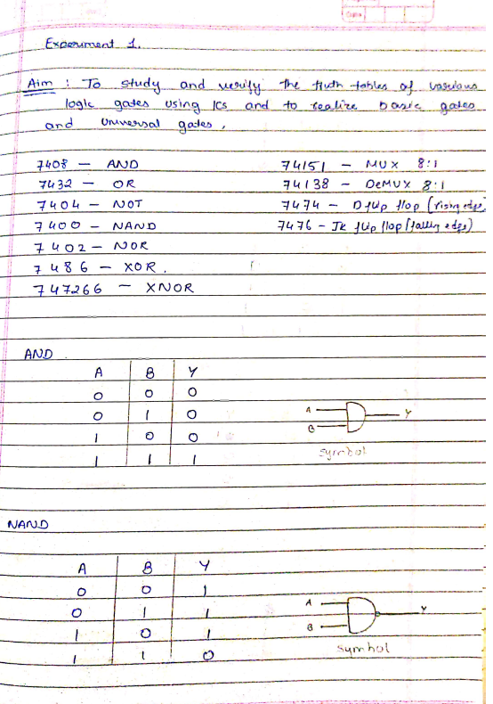­­

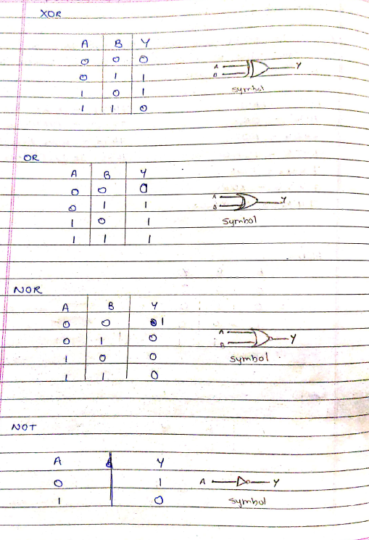

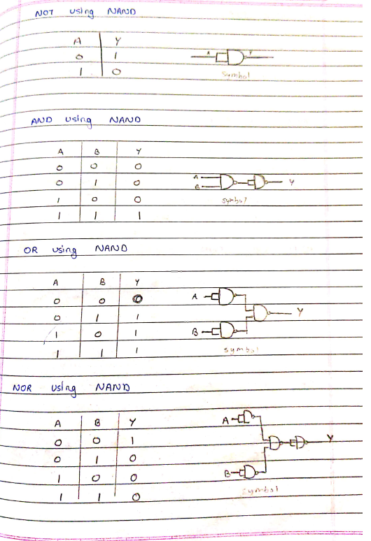

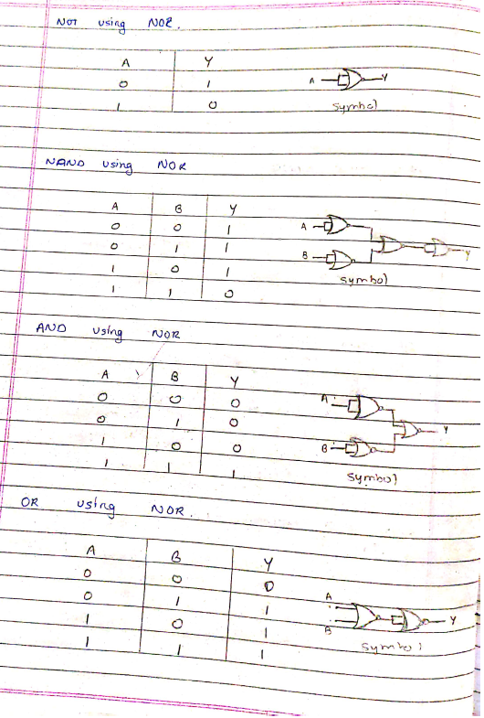

**RESULT:-**

Thus the logic gates are studied and their truth tables were verified.